ZenValetParking – v1.0

Development Environment
- Java JDK 1.8
- Apache Maven 3.6.3
- Eclipse IDE

Project Structure
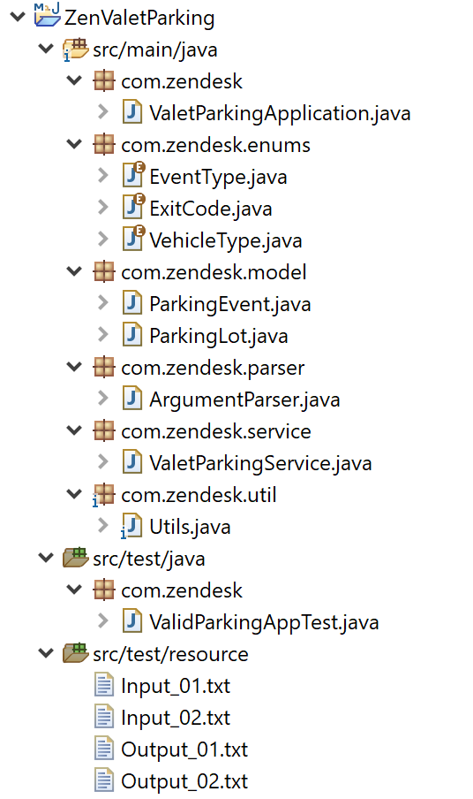

How to Run Program
- Download and Java Runtime Environment. You can use either the JDK or JRE.
- Set the JAVA_HOME system environment variable pointing to the location where you install the JRE.
- In the Path system variable, ensure that %JAVA_HOME%\bin is in the list of Paths.
- Open the Command Prompt (on Windows OS) or Command Shell (on Unix platform), then navigate to the directory where you store the project. Example:
cd C:\ZendeskExercise\
- The file ZenValetParking.jar is packaged inside folder. Run the following command:
java -jar ZenValetParking.jar "<Path to Input File>"

Input Data Format
- The first line indicates the number of parking slots that are present in the space for Cars and Motorcycles respectively:
<Number of Lots for Car> <Number of Lots for Motorcycle>
- Subsequent lines would be 2 types of events:
Enter <motorcycle|car> <vehicle number> <timestamp>
or
Exit <vehicle number> <timestamp>
- All invalid inputs will be rejected.
* Sample input files are available in <your path>\ZendeskExercise\ZenValetParking\src\test\resource

How to Compile
- To browse the project codes, Eclipse is most recommended. Otherwise, any IDE or Text Editor will do.
- Steps for compiling:
  - Download and install Apache Maven 3.6 or above
  - Open Command Prompt, navigate into ZenValetParking directory (pom file’s location) and run the following command:
mvn clean package
  - If build is success, you can find the compiled jar file in generated target folder.

Flexibility and Extensibility
In addition to Cars and Motorcycles, the program can be easily updated to support other vehicle types in the future. For example, when the valet park has additional parking spaces for buses, we just simply add Bus into the VehicleType enum and re-compile the program. No extra coding is required.

Approach and limitations
- I tried to use the TDD approach: creating tests, resolving them, improving the solution, etc.
- Input validation must be strong. With anything other than a valid command resulting in a rejection/error message. However, at the moment, the error message is still not so clear and specific for users to understand the mistake.
- I have not specified the maximum size of the valet park. The limit may depend on its actual capacity. So, it might be reasonable to set a size.
- As for the minimum parking lots, I was binding that the number a non-negative integer. An 0-lot park is not really feasible, so maybe a larger minimum size would make sense.

